Cylindrical Straight-Line Generator

Definition
# Source: AI Source: Provided by: [Data Path: Persons Table -> ID Column: 1, Name_En Column: Motasem Essam] -> From: [ChatGPT] on [7/25/2026]
A Cylindrical Straight-Line Generator is a straight line that moves through space while maintaining a constant direction and continuously intersecting a fixed curve called the directrix.
The successive positions of this moving straight line form a Cylindrical Surface.
Each individual position of the moving line is called a Generator Element or Element of the Cylindrical Surface.
The defining characteristic is that all generators are parallel to one another. The shape of the directrix determines the cross-sectional shape of the resulting cylindrical surface.

Geometric Representation
# Source: AI Source: Provided by: [Data Path: Persons Table -> ID Column: 1, Name_En Column: Motasem Essam] -> From: [ChatGPT] on [7/25/2026]
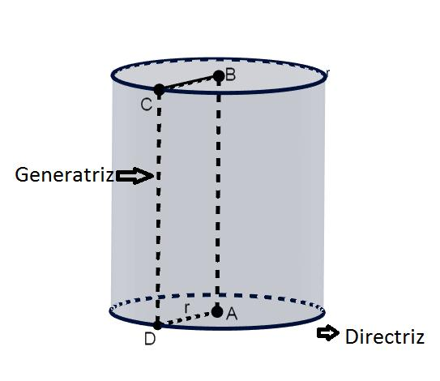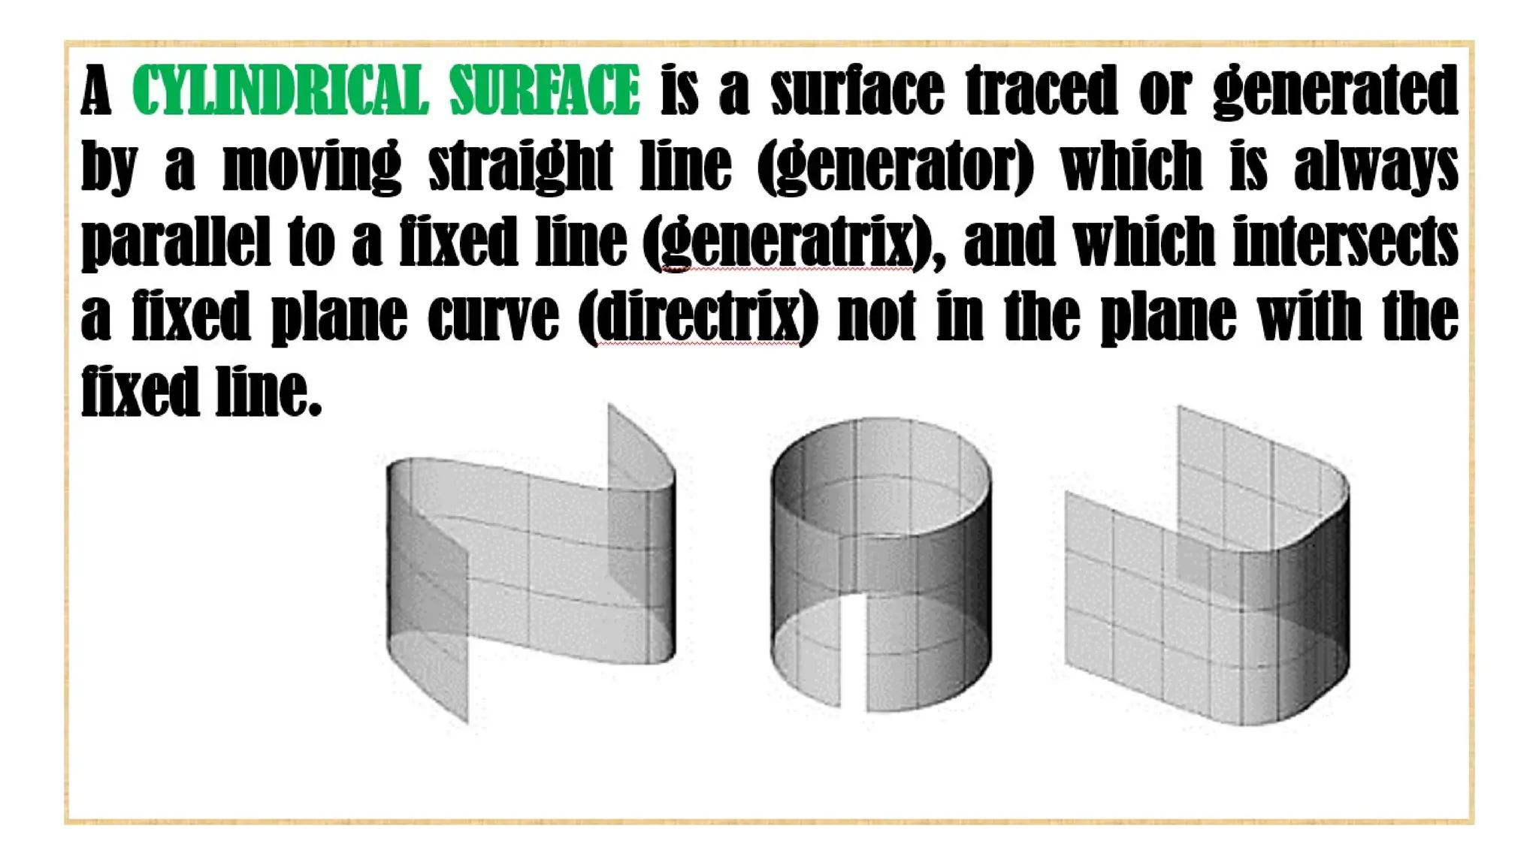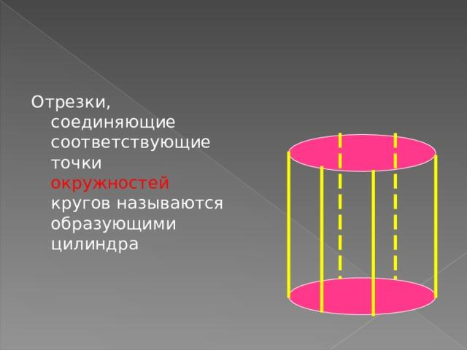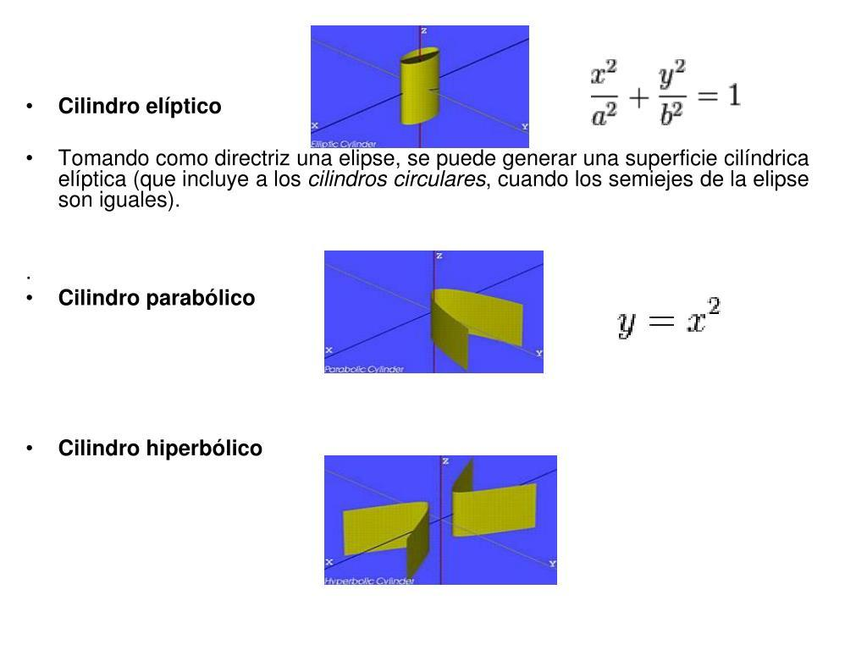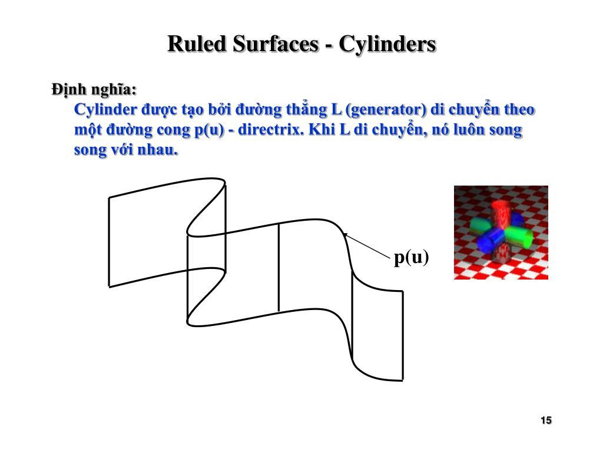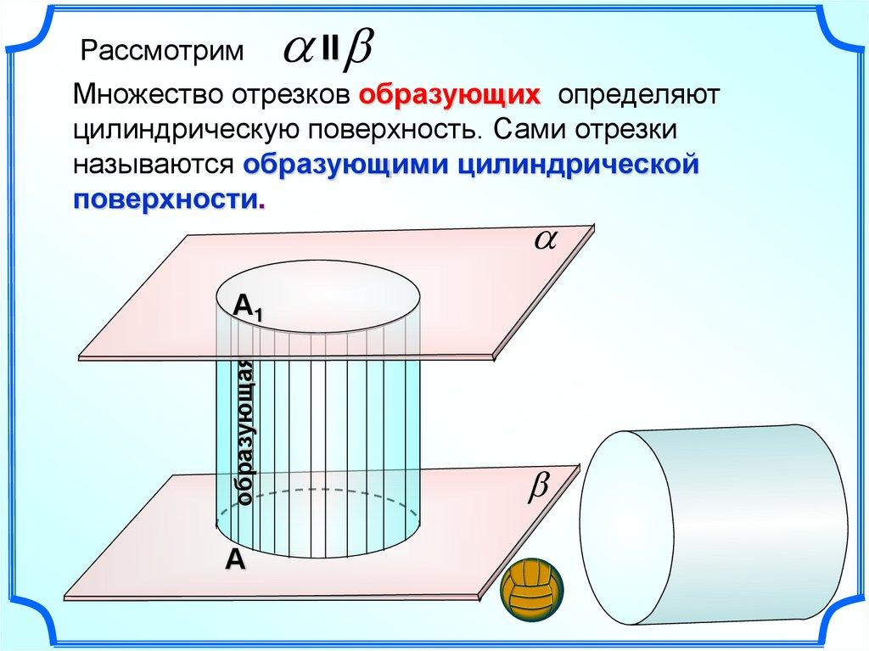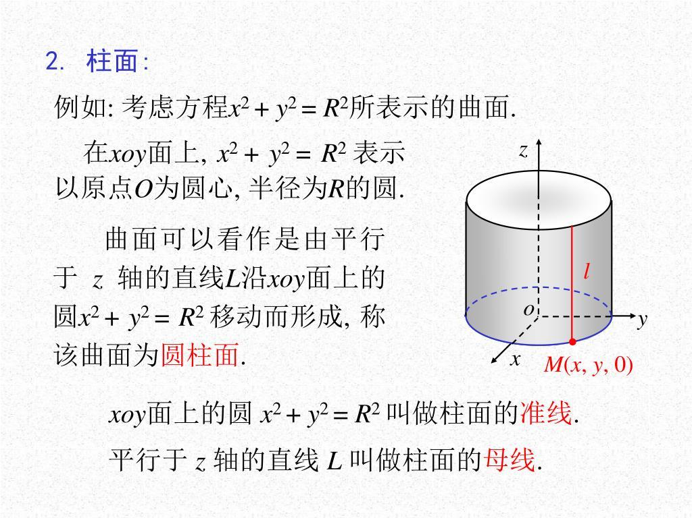

Geometric Structure
# Source: AI Source: Provided by: [Data Path: Persons Table -> ID Column: 1, Name_En Column: Motasem Essam] -> From: [ChatGPT] on [7/25/2026]
A cylindrical straight-line generator consists of the following geometric elements:
- Generating Line: The moving straight line that produces the cylindrical surface.
- Directrix: The fixed curve intersected by the generating line.
- Direction: The fixed direction maintained by all generating lines.
- Generator Elements: The successive positions of the generating line on the surface.
- Cylindrical Surface: The surface formed by the complete family of parallel generating lines.
- Axis Direction: A reference direction parallel to the generators.

Fundamental Elements
# Source: AI Source: Provided by: [Data Path: Persons Table -> ID Column: 1, Name_En Column: Motasem Essam] -> From: [ChatGPT] on [7/25/2026]
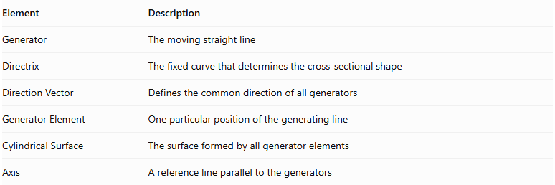
Element | Description
Generator | The moving straight line
Directrix | The fixed curve that determines the cross-sectional shape
Direction Vector | Defines the common direction of all generators
Generator Element | One particular position of the generating line
Cylindrical Surface | The surface formed by all generator elements
Axis | A reference line parallel to the generators
Important distinction: The directrix does not have to be circular. It may be elliptical, parabolic, hyperbolic, polygonal, or another suitable curve.

Types of Cylindrical Straight-Line Generators

Right Cylindrical Generator
# Source: AI Source: Provided by: [Data Path: Persons Table -> ID Column: 1, Name_En Column: Motasem Essam] -> From: [ChatGPT] on [7/25/2026]
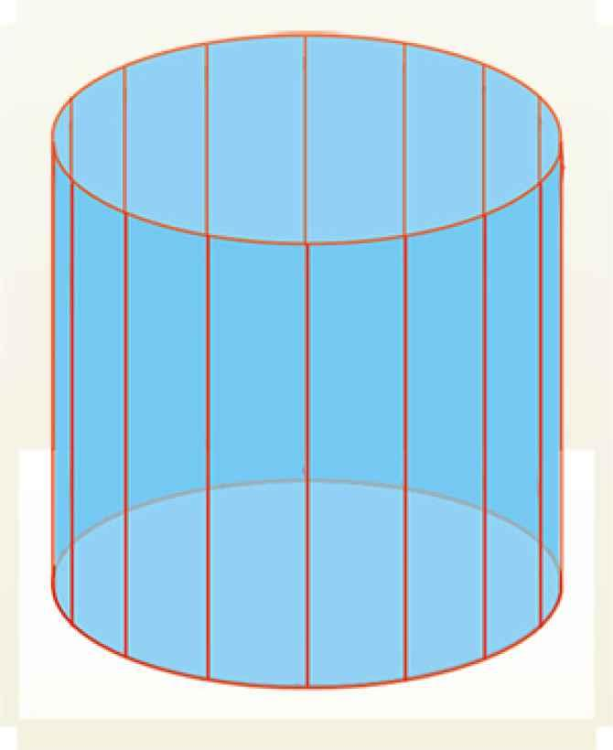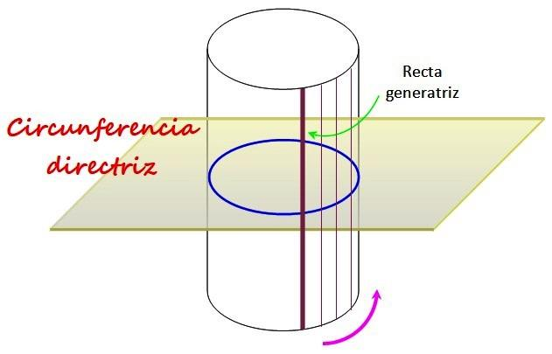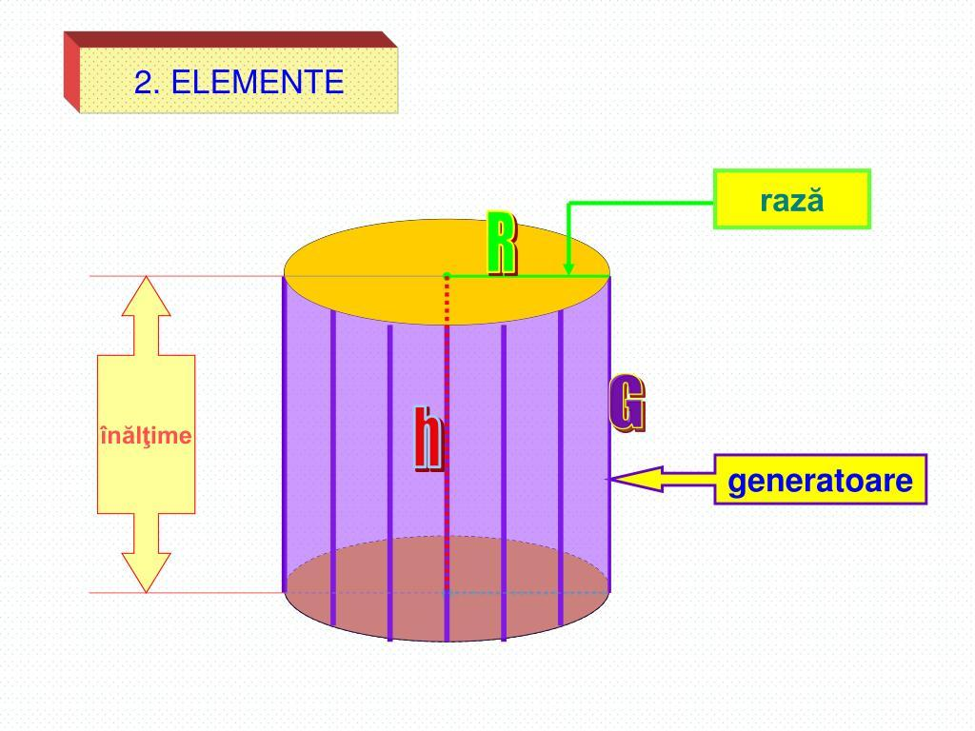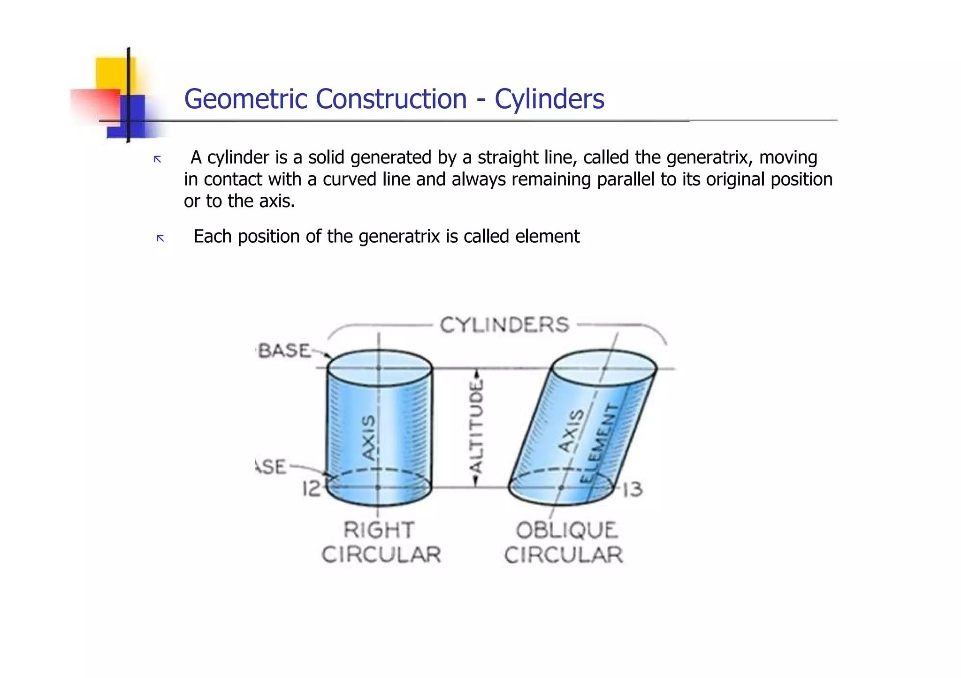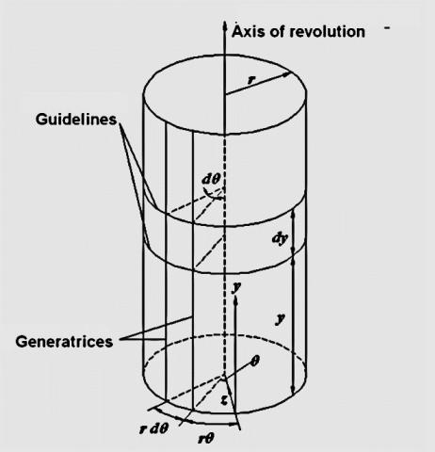
A Right Cylindrical Generator is a straight-line generator whose direction is perpendicular to the plane of the base or directrix when the directrix lies in that plane.
Its successive positions are parallel and perpendicular to the base plane.
Characteristics:
- All generators are parallel.
- All generators are perpendicular to the base plane.
- The cylinder's axis is perpendicular to its base plane.
- The perpendicular distance between the parallel base planes defines the cylinder's height.
Examples:
- Right Circular Cylinder.
- Right Elliptical Cylinder.
- Right Polygonal Cylinder.

Oblique Cylindrical Generator
# Source: AI Source: Provided by: [Data Path: Persons Table -> ID Column: 1, Name_En Column: Motasem Essam] -> From: [ChatGPT] on [7/25/2026]
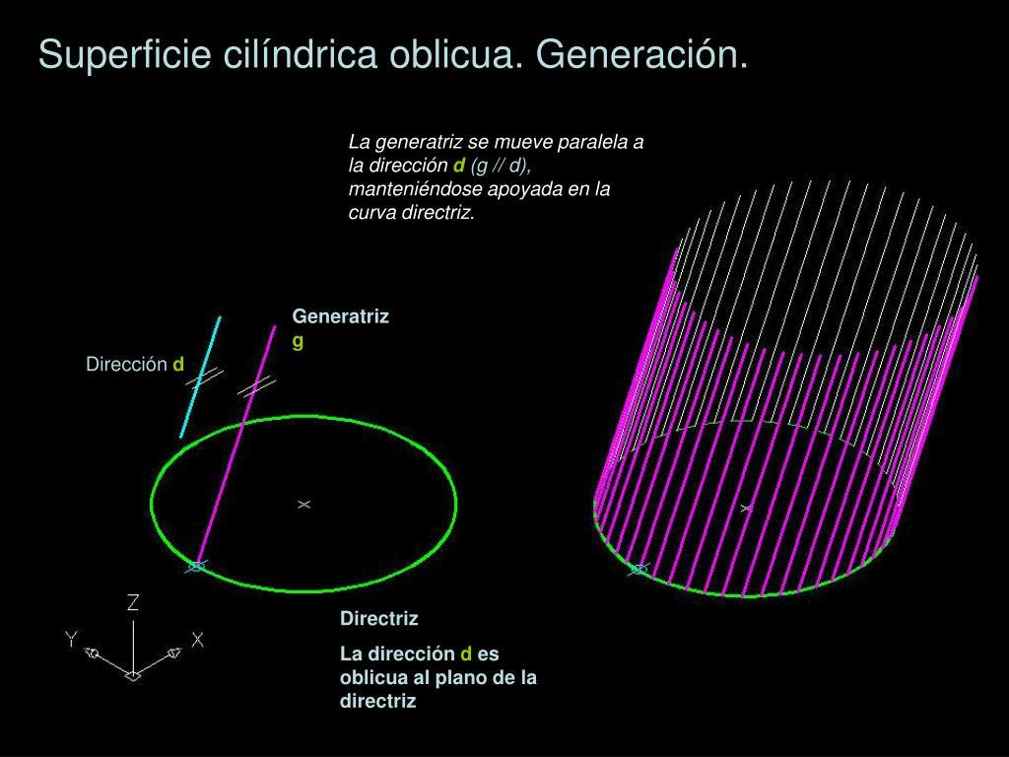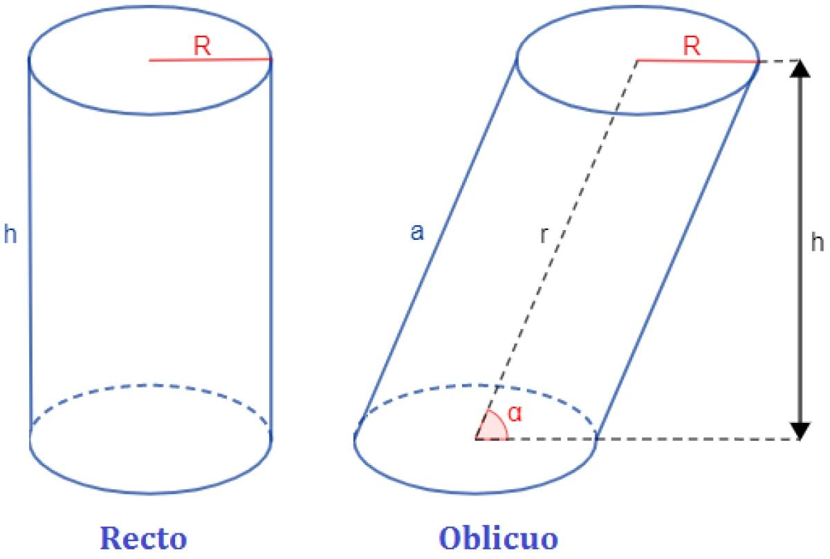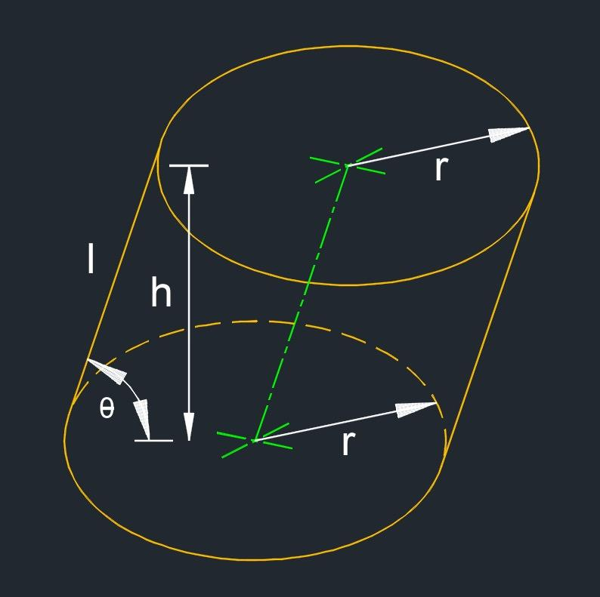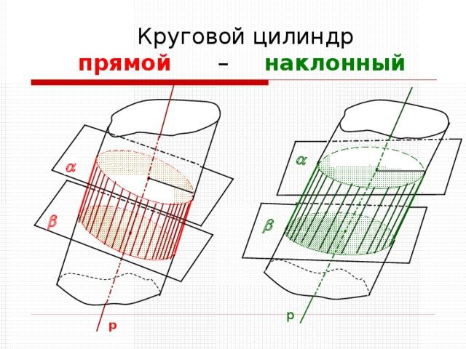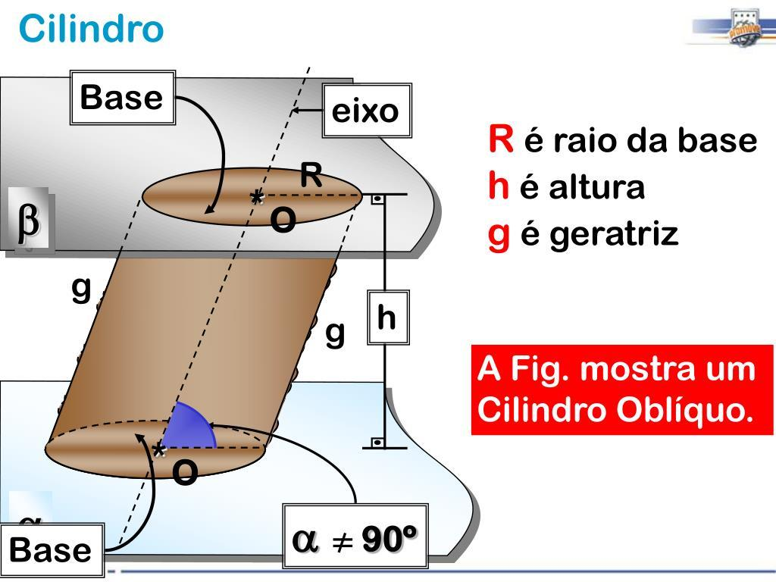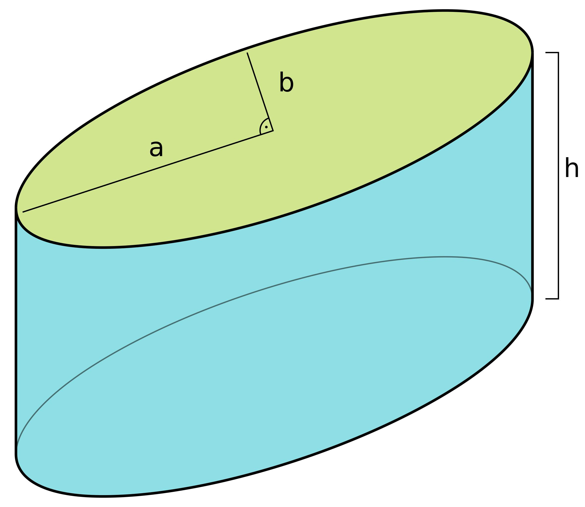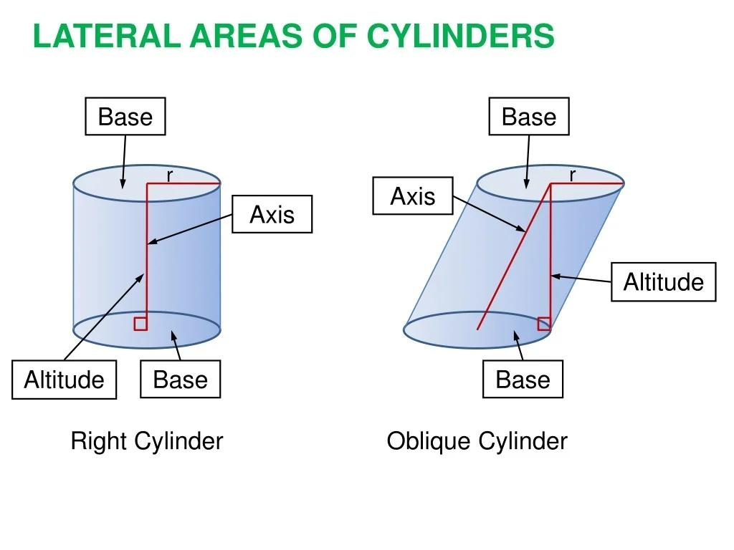
An Oblique Cylindrical Generator is a straight-line generator whose direction is inclined to the perpendicular direction of the base plane.
Its successive positions remain parallel, but they are not perpendicular to the base plane.
Characteristics:
- All generators are parallel.
- The generator direction is inclined to the base plane's normal.
- The cylinder's axis is oblique to the base plane.
- The lateral surface is inclined relative to the bases.
Examples:
- Oblique Circular Cylinder.
- Oblique Elliptical Cylinder.
- Oblique Polygonal Cylinder.
Classification note: Right and oblique describe the orientation of the generators relative to the base plane. They are not different mathematical mechanisms of generating a cylinder; both use parallel straight-line generators.

Classification According to the Directrix
# Source: AI Source: Provided by: [Data Path: Persons Table -> ID Column: 1, Name_En Column: Motasem Essam] -> From: [ChatGPT] on [7/25/2026]
A cylindrical straight-line generator can also be classified according to the shape of its directrix.
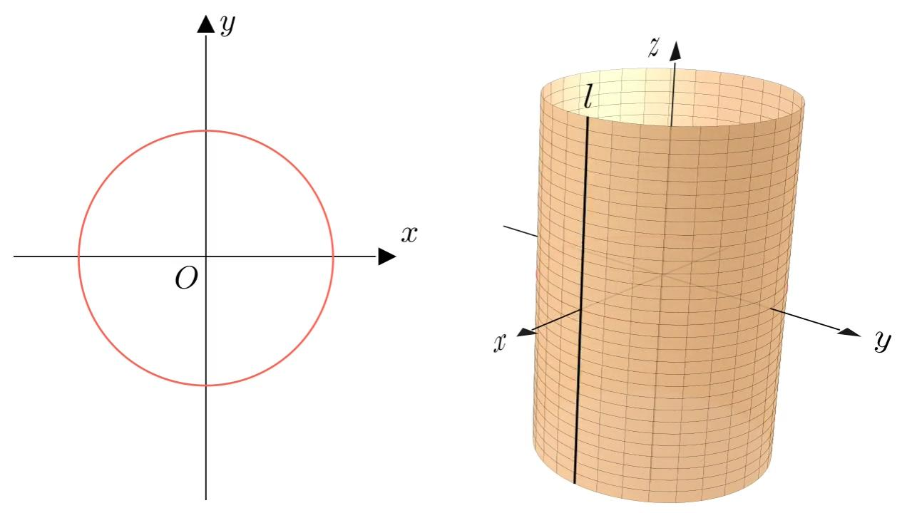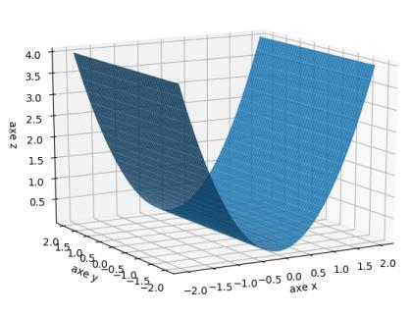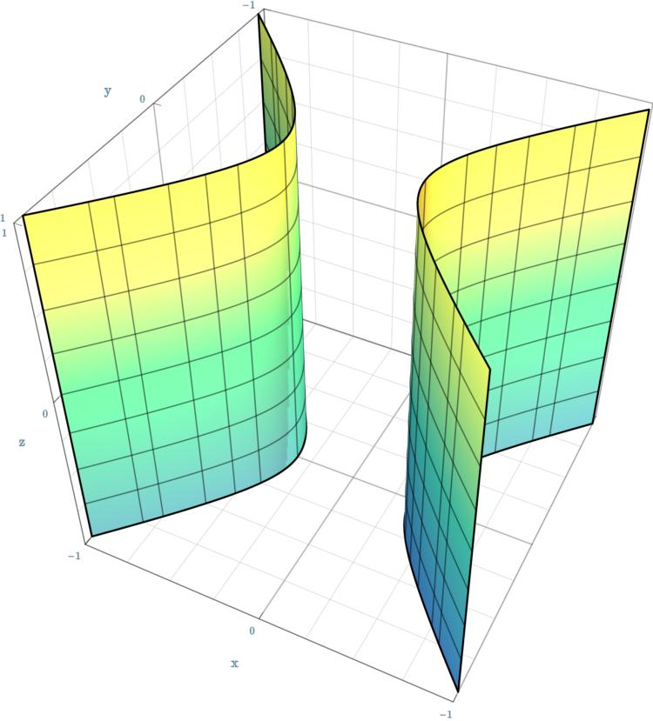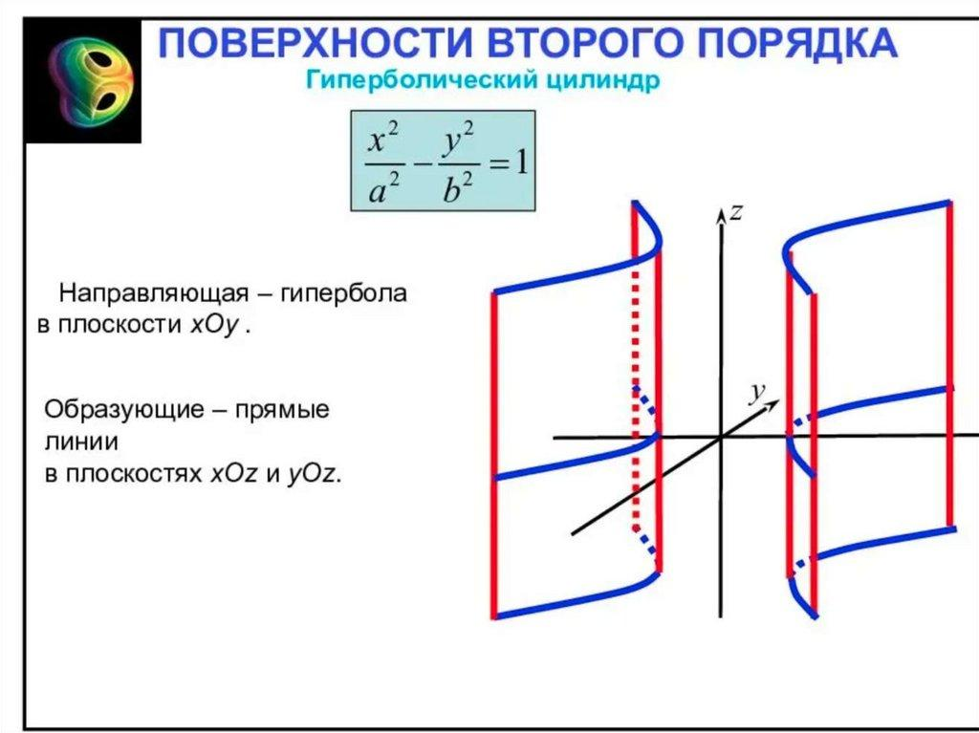

Circular-Directrix Cylindrical Generator
# Source: AI Source: Provided by: [Data Path: Persons Table -> ID Column: 1, Name_En Column: Motasem Essam] -> From: [ChatGPT] on [7/25/2026]
The directrix is a circle, and parallel straight-line generators form a circular cylindrical surface.
Example: Circular Cylinder.

Elliptical-Directrix Cylindrical Generator
# Source: AI Source: Provided by: [Data Path: Persons Table -> ID Column: 1, Name_En Column: Motasem Essam] -> From: [ChatGPT] on [7/25/2026]
The directrix is an ellipse, producing an elliptical cylindrical surface.
Example: Elliptical Cylinder.

Parabolic-Directrix Cylindrical Generator
# Source: AI Source: Provided by: [Data Path: Persons Table -> ID Column: 1, Name_En Column: Motasem Essam] -> From: [ChatGPT] on [7/25/2026]
The directrix is a parabola, producing a parabolic cylindrical surface.
Example: Parabolic Cylinder.

Hyperbolic-Directrix Cylindrical Generator
# Source: AI Source: Provided by: [Data Path: Persons Table -> ID Column: 1, Name_En Column: Motasem Essam] -> From: [ChatGPT] on [7/25/2026]
The directrix is a hyperbola, producing a hyperbolic cylindrical surface.
Example: Hyperbolic Cylinder.
These are common types of cylindrical surfaces classified by their directrices.

Mathematical Representation
# Source: AI Source: Provided by: [Data Path: Persons Table -> ID Column: 1, Name_En Column: Motasem Essam] -> From: [ChatGPT] on [7/25/2026]
A cylindrical straight-line generator can be represented using a directrix and a constant direction vector.

General Parametric Equation
# Source: AI Source: Provided by: [Data Path: Persons Table -> ID Column: 1, Name_En Column: Motasem Essam] -> From: [ChatGPT] on [7/25/2026]
Let:
- $c(u)$ represent the directrix.
- $d$ represent the constant direction vector.
- $v$ represent the position along each generator.
The cylindrical surface is represented by:
$$\boxed{X(u,v)=c(u)+vd}$$
Where:
- $u$ determines the position along the directrix.
- $v$ determines the position along the generating line.
- $d$ remains constant for all generators.
This constant direction is the defining mathematical property of a cylindrical surface.

Cartesian Parametric Representation
# Source: AI Source: Provided by: [Data Path: Persons Table -> ID Column: 1, Name_En Column: Motasem Essam] -> From: [ChatGPT] on [7/25/2026]
For a circular cylinder of radius $r$, with its axis parallel to the $z$-axis:
$$x=rcosu$$
$$y=rsinu$$
$$z=v$$
Where:
$$0≤u≤2π$$
The corresponding cylindrical surface equation is:
$$\boxed{x^{2}+y^{2}=r^{2}}$$
Each fixed value of $u$ identifies one straight-line generator parallel to the $z$-axis.

Right Cylindrical Generator
# Source: AI Source: Provided by: [Data Path: Persons Table -> ID Column: 1, Name_En Column: Motasem Essam] -> From: [ChatGPT] on [7/25/2026]
For a vertical right circular cylinder:
$$d=(0,0,1)$$
The generators are perpendicular to the horizontal base plane.

Oblique Cylindrical Generator
# Source: AI Source: Provided by: [Data Path: Persons Table -> ID Column: 1, Name_En Column: Motasem Essam] -> From: [ChatGPT] on [7/25/2026]
For an oblique cylindrical surface, an example of a constant direction vector is:
$$d=(p,q,r)$$
where the direction is not perpendicular to the base plane.
The surface can be expressed as:
$$\boxed{X(u,v)=c(u)+v(p,q,r)}$$
The direction vector remains unchanged for every generator.

Geometric Properties
# Source: AI Source: Provided by: [Data Path: Persons Table -> ID Column: 1, Name_En Column: Motasem Essam] -> From: [ChatGPT] on [7/25/2026]
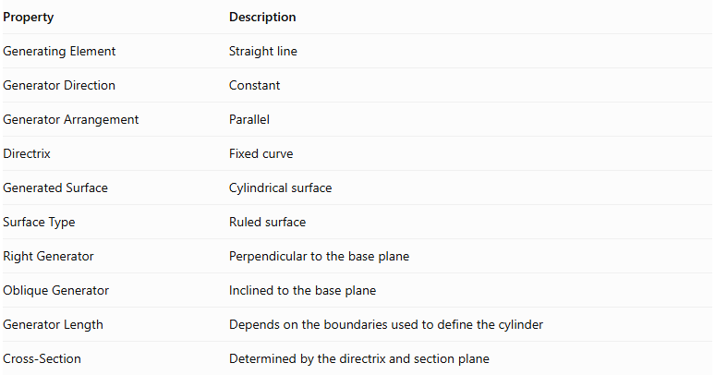
Property | Description
Generating Element | Straight line
Generator Direction | Constant
Generator Arrangement | Parallel
Directrix | Fixed curve
Generated Surface | Cylindrical surface
Surface Type | Ruled surface
Right Generator | Perpendicular to the base plane
Oblique Generator | Inclined to the base plane
Generator Length | Depends on the boundaries used to define the cylinder
Cross-Section | Determined by the directrix and section plane

Construction Process
# Source: AI Source: Provided by: [Data Path: Persons Table -> ID Column: 1, Name_En Column: Motasem Essam] -> From: [ChatGPT] on [7/25/2026]
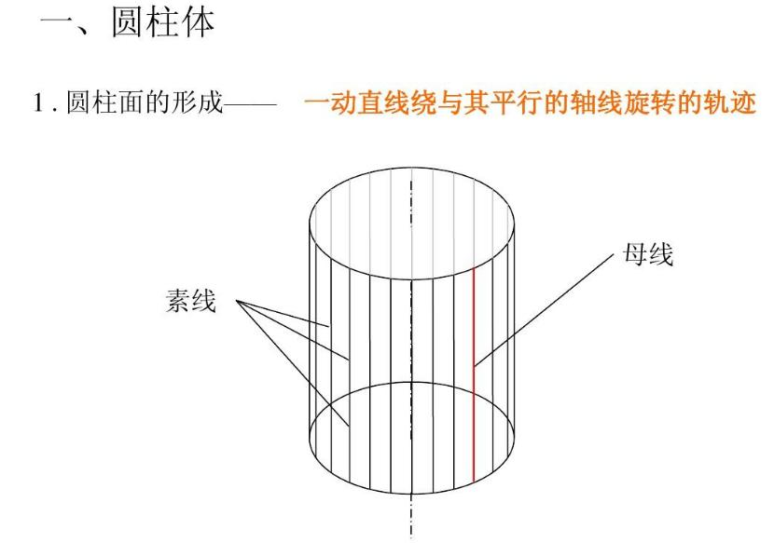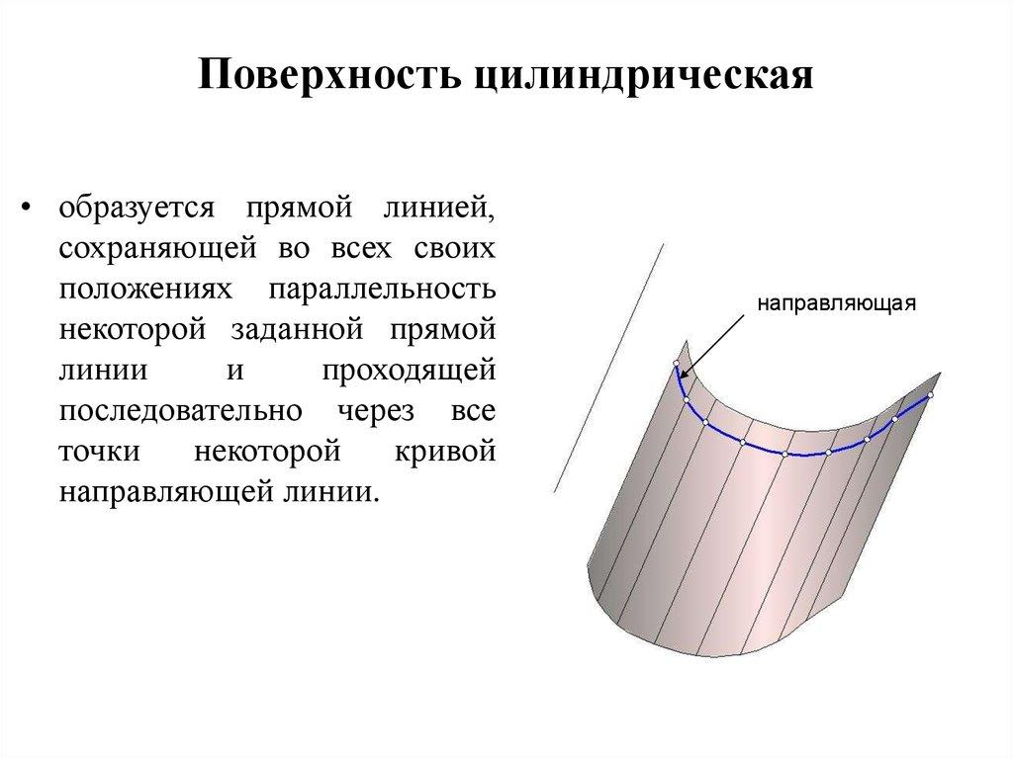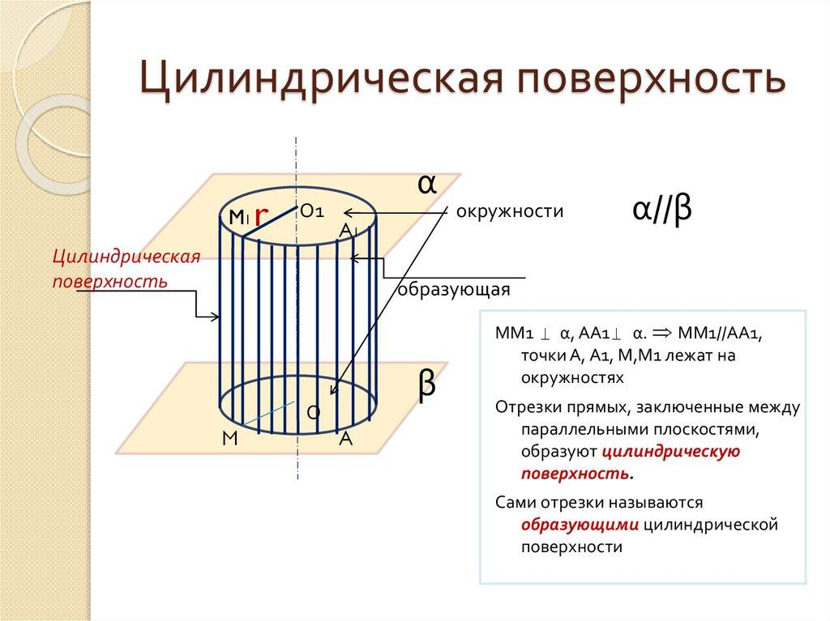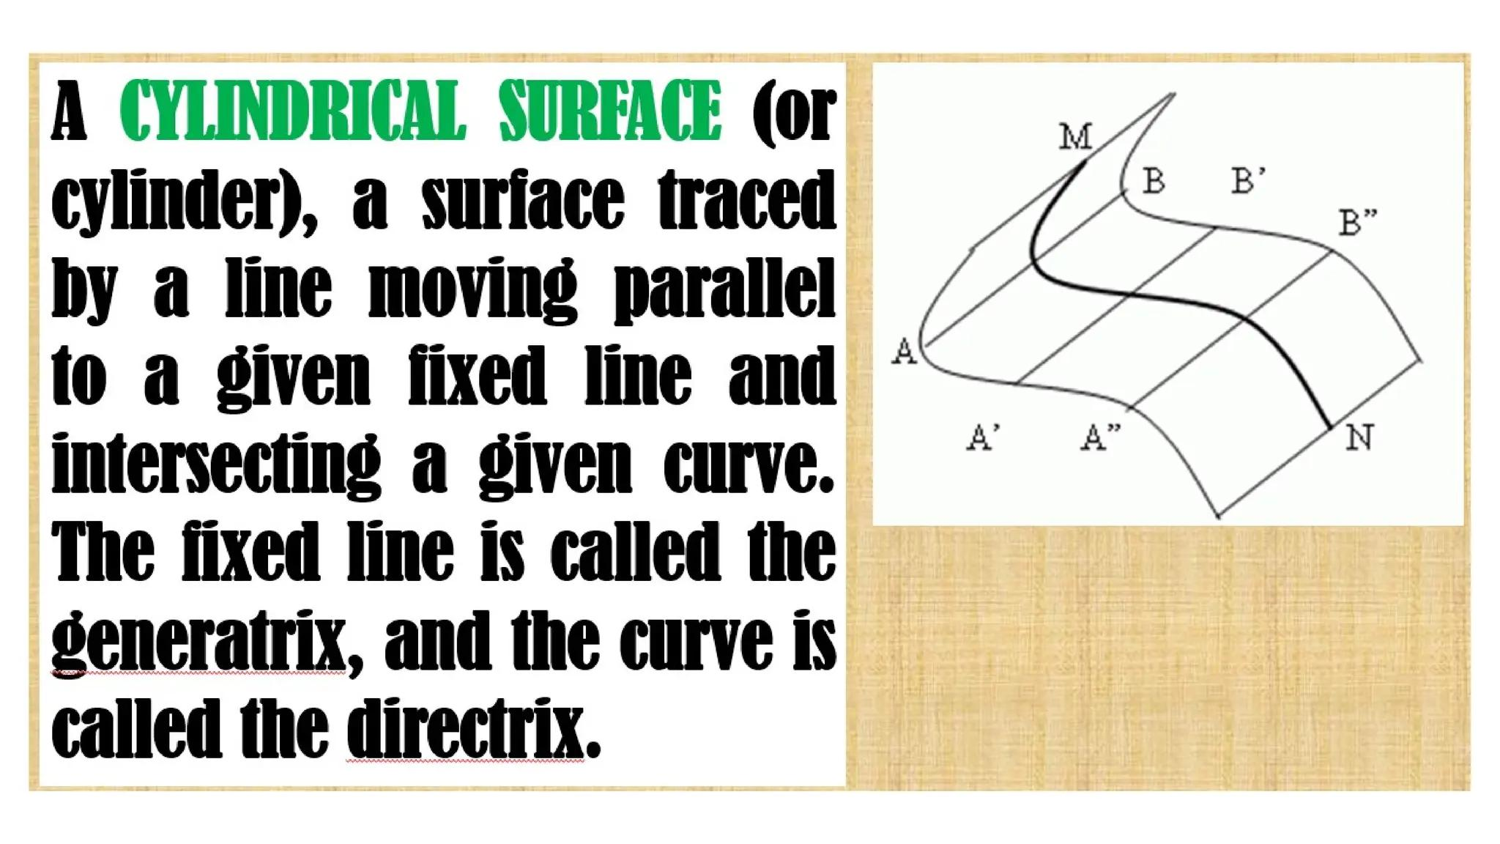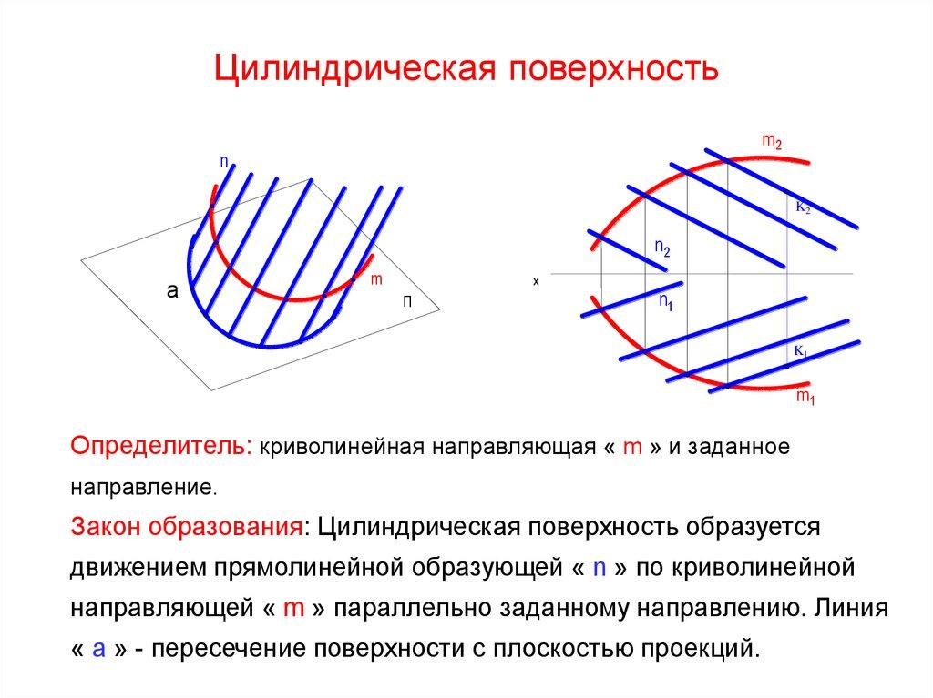
- Define the Directrix: Select a fixed curve that determines the cross-sectional shape.
- Establish the Direction: Define a fixed direction vector for the generating line.
- Position the Generator: Place a straight line through a point on the directrix.
- Maintain Parallelism: Move the line along the directrix while maintaining its direction.
- Generate Successive Positions: Produce a continuous family of parallel straight lines.
- Form the Cylindrical Surface: The union of all generator positions creates the cylindrical surface.
- Define the Cylinder Solid: If a solid is required, use two parallel cutting planes to bound the cylindrical surface.

Generator vs. Directrix vs. Axis
# Source: AI Source: Provided by: [Data Path: Persons Table -> ID Column: 1, Name_En Column: Motasem Essam] -> From: [ChatGPT] on [7/25/2026]
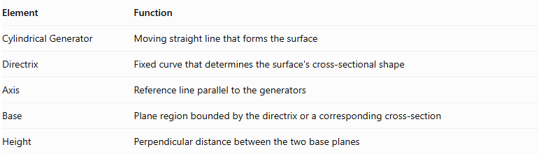
Element | Function
Cylindrical Generator | Moving straight line that forms the surface
Directrix | Fixed curve that determines the surface's cross-sectional shape
Axis | Reference line parallel to the generators
Base | Plane region bounded by the directrix or a corresponding cross-section
Height | Perpendicular distance between the two base planes

Comparison with Other Straight-Line Generators
# Source: AI Source: Provided by: [Data Path: Persons Table -> ID Column: 1, Name_En Column: Motasem Essam] -> From: [ChatGPT] on [7/25/2026]
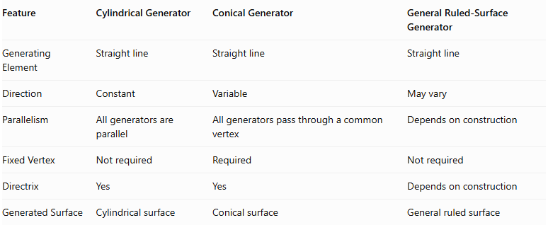
Feature | Cylindrical Generator | Conical Generator | General Ruled-Surface Generator
Generating Element | Straight line | Straight line | Straight line
Direction | Constant | Variable | May vary
Parallelism | All generators are parallel | All generators pass through a common vertex | Depends on construction
Fixed Vertex | Not required | Required | Not required
Directrix | Yes | Yes | Depends on construction
Generated Surface | Cylindrical surface | Conical surface | General ruled surface

Important Distinctions
# Source: AI Source: Provided by: [Data Path: Persons Table -> ID Column: 1, Name_En Column: Motasem Essam] -> From: [ChatGPT] on [7/25/2026]
- Cylindrical Surface vs. Cylinder: A cylindrical surface is the curved two-dimensional boundary; a cylinder is a three-dimensional solid bounded by that surface and two suitable plane sections.
- Generator vs. Axis: The generator is a line on the cylindrical surface, while the axis is a reference line parallel to the generators.
- Generator vs. Directrix: The generator moves while the directrix remains fixed.
- Right vs. Oblique: Both use parallel generators; their difference is the orientation relative to the base plane.
- Circular vs. General Cylindrical Surface: A cylinder does not have to have a circular directrix.

Main Classification
# Source: AI Source: Provided by: [Data Path: Persons Table -> ID Column: 1, Name_En Column: Motasem Essam] -> From: [ChatGPT] on [7/25/2026]
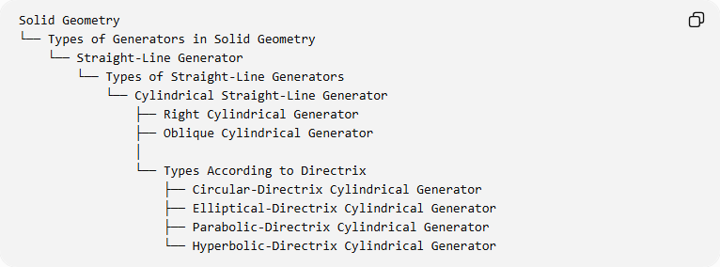
Solid Geometry
└── Types of Generators in Solid Geometry
└── Straight-Line Generator
└── Types of Straight-Line Generators
└── Cylindrical Straight-Line Generator
├── Right Cylindrical Generator
├── Oblique Cylindrical Generator
│
└── Types According to Directrix
├── Circular-Directrix Cylindrical Generator
├── Elliptical-Directrix Cylindrical Generator
├── Parabolic-Directrix Cylindrical Generator
└── Hyperbolic-Directrix Cylindrical Generator

Key Points
# Source: AI Source: Provided by: [Data Path: Persons Table -> ID Column: 1, Name_En Column: Motasem Essam] -> From: [ChatGPT] on [7/25/2026]
- A cylindrical straight-line generator is a moving straight line that generates a cylindrical surface.
- All generators maintain a constant direction and remain parallel.
- The directrix determines the cross-sectional shape of the cylindrical surface.
- Right cylindrical generators are perpendicular to the base plane.
- Oblique cylindrical generators are inclined relative to the base plane.
- Cylindrical surfaces can have circular, elliptical, parabolic, or hyperbolic directrices.
- A cylindrical surface is a ruled surface because it is formed by straight lines.

Conclusion
# Source: AI Source: Provided by: [Data Path: Persons Table -> ID Column: 1, Name_En Column: Motasem Essam] -> From: [ChatGPT] on [7/25/2026]
The Cylindrical Straight-Line Generator is a type of straight-line generator that produces cylindrical surfaces through the continuous movement of a straight line parallel to a fixed direction along a directrix. Its fundamental characteristic is the parallel arrangement of all generating lines, making it the geometric basis for circular, elliptical, parabolic, and hyperbolic cylindrical surfaces.

